Homework
We have been working on company database in this course. The ER model and corresponding relational schema is given. Your task is to create XML instance document to correspond to the data stored in the relational database.
Company ER Model:
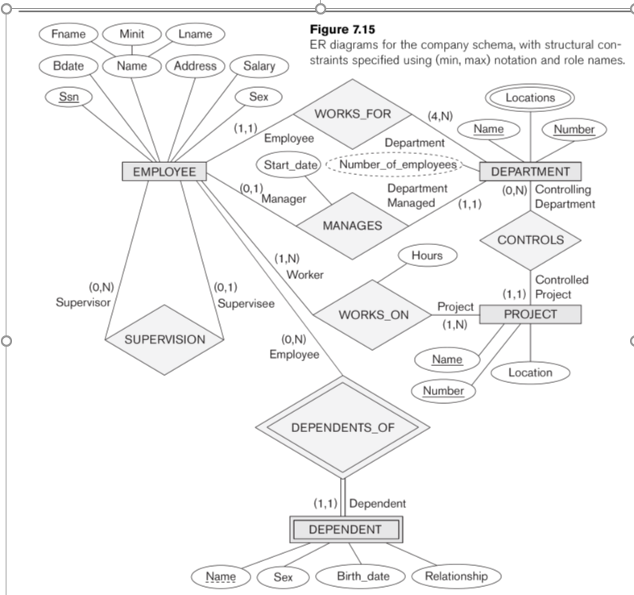

Relational Model:

Relational Database:

XML document:
A part of conversion is done for you. Please completely convert the company database into xml document.

<?xml version="1.0" standalone="yes" ?>
<Departments>
<Department>
<Dname>Research</Dname>
<Dnumber>5</Dnumber>
<Mgr_ssn>333445555</Mgr_ssn>
<Mgr_start_date>1988-05-22</Mgr_start_date>
<Dlocation>Bellaire</Dlocation>
<Dlocation>Sugarland</Dlocation>
<Dlocation>Houston</Dlocation>
</Department>

<Department>
<Dname>Administration</Dname>
<Dnumber>4</Dnumber>
<Mgr_ssn>987654321</Mgr_ssn>
<Mgr_start_date>1995-01-01</Mgr_start_date>
<Dlocation>Stafford</Dlocation>
</Department>
...
</Departments>

Complete the rest of conversion here:

Task 2: Create XML schema documents and XML DTDs to correspond to the ER model given below:

